

语音网关Demo

Specification Version 1.0.0  
  
  
  
Author：SaintEgerLeo

*September 4, 2017*

|  |  |  |  |
| --- | --- | --- | --- |
| Rev. | Date | Contents of Revision Change | Remark |
| 1.0.0 | 2017-09-04 | Initial release |  |

1. 产品简介

* 语音网关Demo是一个将PSTN电话与VoIP网关互转的Demo。
* 包含两个FXS口，两个FXO口，一个Wan口，四个Lan口。
* FXS口需要支持断电逃生<思路：通过FXO将PSTN送过来的电转到FXS，以便FXS提供电给到FXO终端>。
* 支持路由模式和交换模式。
* 语音算法：支持NPL分组语音单元协议的LEC、动态抖动缓冲、128 ms-tall-length硬件回声消除算法、传真信号音检测并可自动切换为G.711编码
* 语音和传真编码：G.711A-law/U-law，G.722，G.723.1 5.3K/6.3K，G.726，G.729A/B，iLBC，GSM、AAL2-G.726-32，ADPCM，T.38。
* 支持DTMF检测、DTMF生成；支持FSK检测、FSK生成。
* 终端管理和自动部署功能：支持SIP终端即插即用自动部署功能(含括DHCP Option 66/组播SIP SUBSCRIBE /mDNS自动检测和配置)。
* 通话功能：呼叫停泊，呼叫转移，呼叫前转，免打扰，振铃组，代答组，传呼/对讲等功能
* 录音功能：将通过该Demo的语音模拟数据保存成任意语音数字格式；注意电话两端的语音不能单独保存，需要合成为整体。
* 功能参考：[www.grandstream.com.cn/Prd_view.aspx?id=162](http://www.grandstream.com.cn/Prd_view.aspx?id=162)
* 目前大致方案框图：

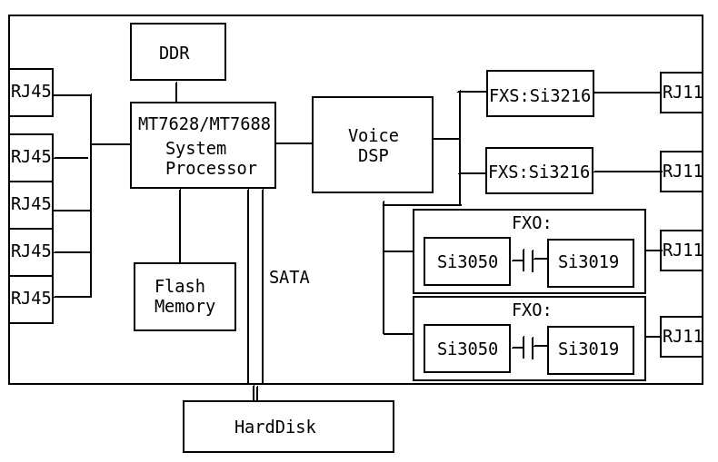

2. 需求点

2.1. 硬件配置

2FXS+2FXO+1WAN+4LAN+1SATA HardDisk，需要硬件设计的所有资料。

|  |  |  |  |
| --- | --- | --- | --- |
| **项目** | **功能** | **配置** | **备注** |
| **硬件配置** |  |  |  |
|  |  |  |
|  |  |  |
|  |  |  |
|  |  |  |
|  |  |  |
|  |  |  |
|  |  |  |
|  |  |  |
|  |  |  |
|  |  |  |
|  |  |  |
|  |  |  |
|  |  |  |
|  |  |  |
|  |  |  |
|  |  |  |
|  |  |  |
|  |  |  |
|  |  |  |
|  |  |  |
|  |  |  |
|  |  |  |

2.2. 结构需求

Demo无明显结构需求

|  |  |  |  |
| --- | --- | --- | --- |
| **项目** | **功能** | **配置** | **备注** |
| **结构需求** |  |  |  |
|  |  |  |
|  |  |  |
|  |  |  |
|  |  |  |
|  |  |  |
|  |  |  |
|  |  |  |
|  |  |  |
|  |  |  |
|  |  |  |
|  |  |  |
|  |  |  |
|  |  |  |
|  |  |  |
|  |  |  |
|  |  |  |
|  |  |  |
|  |  |  |
|  |  |  |
|  |  |  |
|  |  |  |
|  |  |  |
|  |  |  |
|  |  |  |
|  |  |  |
|  |  |  |

2.3. 软件需求

OpenWRT+Asterisk，需要软件设计的所有资料，以及说明文档。

|  |  |  |  |
| --- | --- | --- | --- |
| **项目** | **功能** | **配置** | **备注** |
| **DRIVER** |  |  |  |
|  |  |  |
|  |  |  |
|  |  |  |
|  |  |  |
|  |  |  |
|  |  |  |
|  |  |  |

|  |  |  |  |
| --- | --- | --- | --- |
| **项目** | **功能** | **配置** | **备注** |
| **Application** |  |  |  |
|  |  |  |
|  |  |  |
|  |  |  |
|  |  |  |
|  |  |  |
|  |  |  |
|  |  |  |

|  |  |  |  |
| --- | --- | --- | --- |
| **项目** | **功能** | **配置** | **备注** |
| **System** |  |  |  |
|  |  |  |
|  |  |  |
|  |  |  |
|  |  |  |
|  |  |  |
|  |  |  |
|  |  |  |

3. 任务分配

|  |  |  |  |  |  |  |
| --- | --- | --- | --- | --- | --- | --- |
| **任务** | **起始时间** | **周期(天)** | **责任人** | **评审人** | **结果** | **备注** |
| **硬件原理验证** |  |  |  |  |  |  |
| **电路板**  **设计** |  |  |  |  |  |  |
| **投板** |  |  |  |  |  |  |
| **软件开发** |  |  |  |  |  |  |
| **调试** |  |  |  |  |  |  |

4. 问题记录

|  |  |  |
| --- | --- | --- |
| **问题** | **解决** | **备注** |
|  |  |  |
|  |  |  |
|  |  |  |
|  |  |  |
|  |  |  |
|  |  |  |
|  |  |  |
|  |  |  |
|  |  |  |
|  |  |  |
|  |  |  |
|  |  |  |
|  |  |  |
|  |  |  |
|  |  |  |
|  |  |  |
|  |  |  |
|  |  |  |
|  |  |  |
|  |  |  |
|  |  |  |