说明
- 要制作的ADSL猫的使用方法如附图，是石油测井中典型用法。功能是：地面将控制命令下发到井下各仪器，井下各仪器将数据上传到地面。通信猫要用两个，一个在地面，一个在井下，用电缆连接。工作时这样连接：计算机+交换机+制作的通信猫A+双绞线（10000米，电缆）+制作的通信猫B+以太网路由器数据发送网卡。工作过程如下。下行过程：计算机以TCP/IP协议发送命令数据，通过制作的通信猫A调制、驱动，经过双绞线传输，达到制作的通信猫B，由制作的通信猫B解调，发送网卡执行命令。上行过程：网卡采集的数据，以以太网发送至制作的通信猫B调制，驱动至双绞线传输，制作的通信猫A接收数据并解调，输入计算机。
- 试验板电路使用的元器件可以使用常温器件和功能更高器件，但该器件必须有耐高温性能的产品。因该制作的通信猫要工作在175度环境中。
- Pcb板宽度55mm，长度根据实际确定。
- 上一次发给你的英文资料制作的调制解调器是2000年以前产品，可能还没有专用芯片。这一次发给你的附图是现在使用的一个方案。 唯一问题是U7芯片耐温不够。
- 也可以使用其他方案，但要求能在175度工作，且AFE要采用DMT调制。
- 提供资料：原理图，PCB板图，源程序，器件清单，开发工具。
据我了解 用tc3162+tc3086制造的ADSL基本能达到要求。

附件2 ADSL板原理图
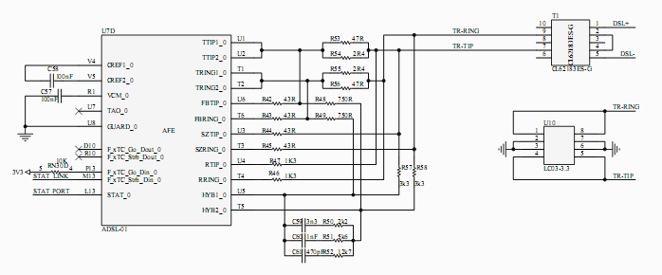
AEF模块原理图
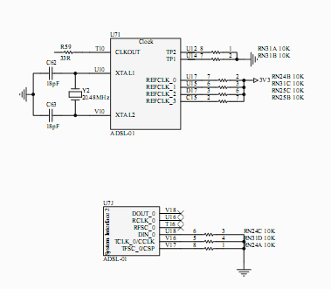 Clock模块原理图

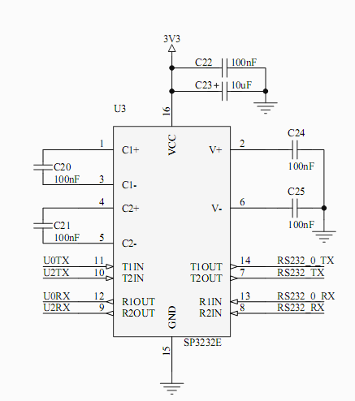 RS232模块原理图
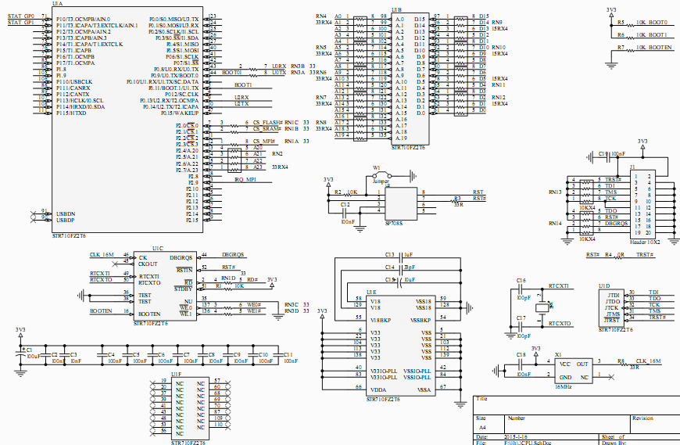
CPU模块原理图
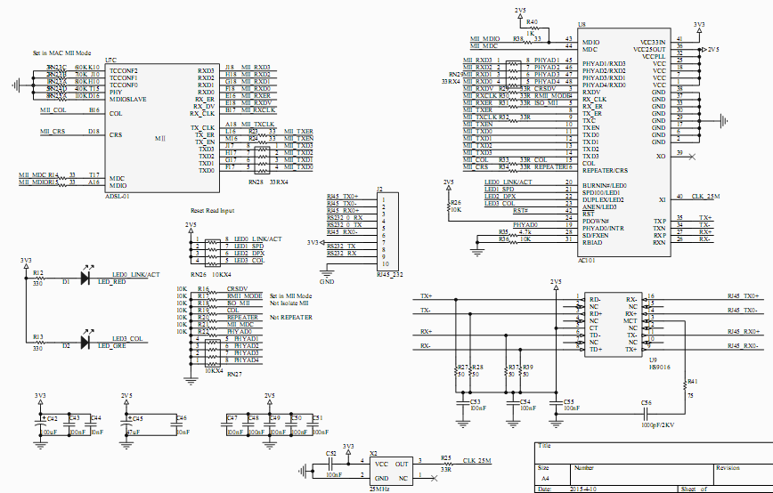
MⅡ—PHY模块原理图
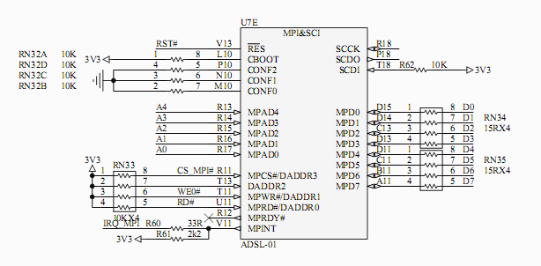
MCU_interface原理图
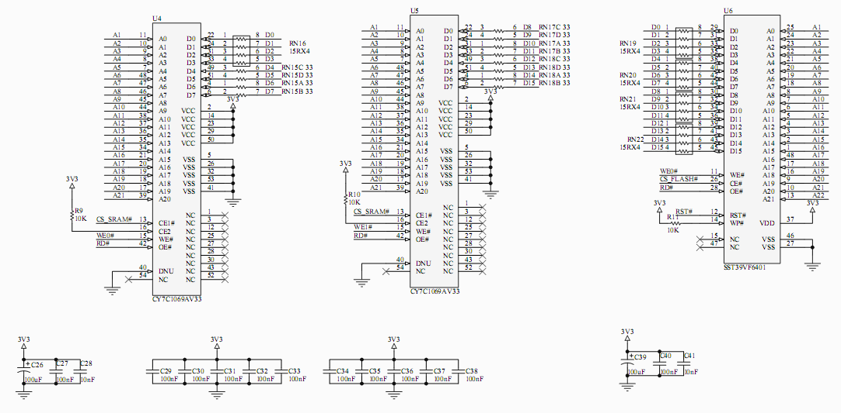
memory模块原理图
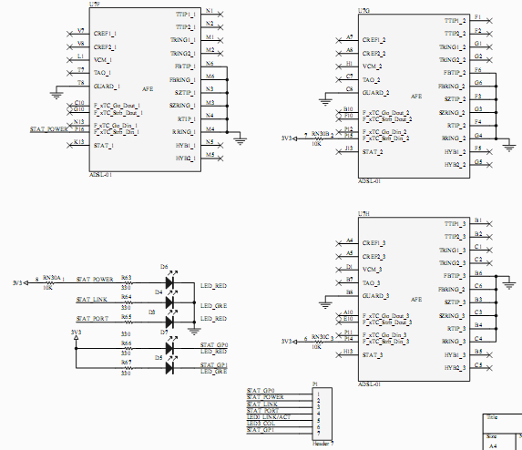
Misc_Stat模块原理图
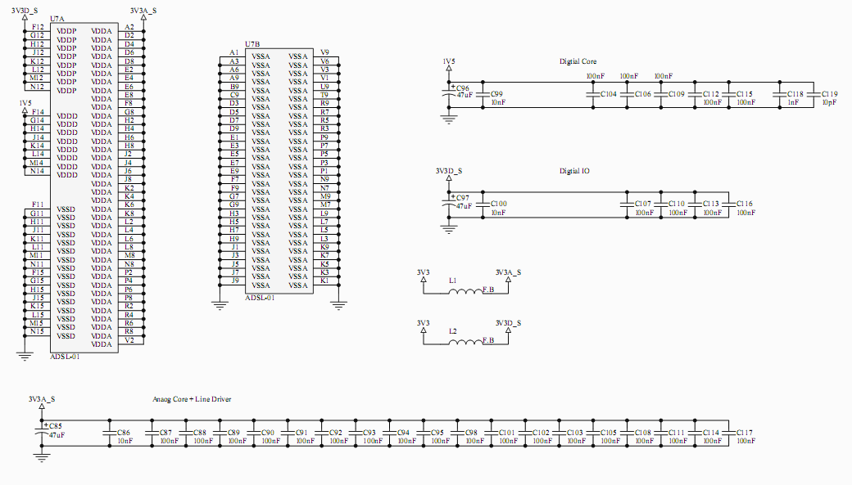
SOC—power原理图

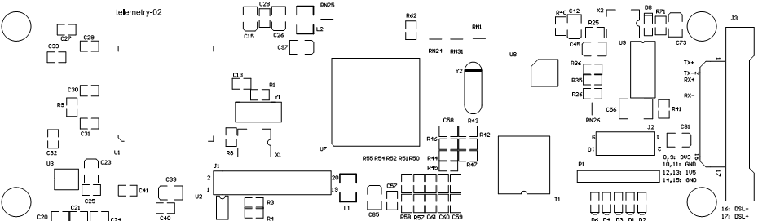
ADSL板top器件布局
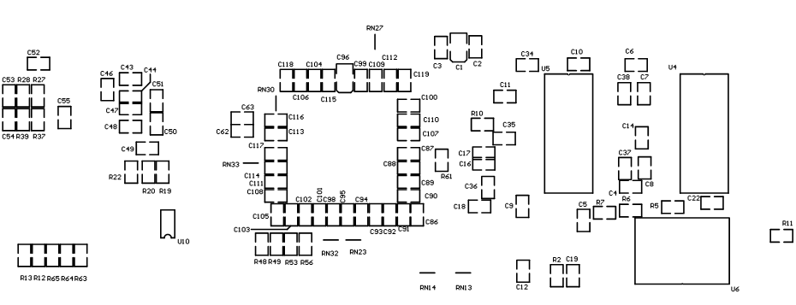
bottom器件布局

ADSL板元器件清单
Bill of Materials |  |  | Bill of Materials For PCB Document [telemetry-02.PcbDoc]
Source Data From: |  | telemetry-02.PcbDoc
Project: |  | 580NTGR
Variant: |  | None
Creation Date: | 2016/1/14 | 10:24:18
Print Date: | 31-Jul-17 | #######
Designator | Footprint |  | Comment |  | Quantity
C1, C26, C39, C42, C73, C81 | SMD_CAP_B |  | 100uF |  | 6 | 黑色10uF代替
C2, C4, C5, C6, C7, C8, C9, C10, C11, C12, C18, C19, C20, C21, C22, C24, C25, C27, C29, C30, C31, C32, C33, C34, C35, C36, C37, C38, C40, C43, C47, C48, C49, C50, C51, C52, C53, C54, C55, C57, C58, C87, C88, C89, C90, C91, C92, C93, C94, C95, C98, C101, C102, C103, C104, C105, C106, C107, C108, C109, C110, C111, C112, C113, C114, C115, C116, C117 | CR2012-0805 |  | 100nF |  | 68
C3, C28, C41, C44, C46, C86, C99, C100 | CR2012-0805 |  | 10nF |  | 8
C13 | CR2012-0805 |  | 1uF |  | 1
C14 | CR2012-0805 |  | 33pF |  | 1
C15, C23 | SMD_CAP_B |  | 10uF |  | 2 | 黑色
C16, C17 | CR2012-0805 |  | 100pF |  | 2
C45, C85, C96, C97 | SMD_CAP_B |  | 47uF |  | 4 | 黑色10uF代替
C56 | 1812 |  | 1000pF/2KV |  | 1
C59 | CR2012-0805 |  | 3n3 |  | 1
C60, C118 | CR2012-0805 |  | 1nF |  | 2
C61 | CR2012-0805 |  | 470pF |  | 1
C62, C63 | CR2012-0805 |  | 18pF |  | 2
C119 | CR2012-0805 |  | 10pF |  | 1
D1, D3, D6, D8 | 0805DIODE |  | LED_RED |  | 4
D2, D4 | 0805DIODE |  | LED_GRE |  | 2
J1 | HDR2X10 |  | Header 10X2 |  | 1
J2 | HDR2X5 |  | RJ45_232 |  | 1
J3 | 17PIN |  | 17PIN |  | 1
L1, L2 | 1210 |  | Inductor |  | 2 | 短接
P1 | HDR1X7 |  | Header 7 |  | 1
R1, R2, R5, R6, R7, R9, R10, R11, R19, R20, R22, R26, R36, R62 | CR2012-0805 |  | 10k |  | 14
R3, R8, R25 | CR2012-0805 |  | 33R |  | 3
R4 | CR2012-0805 |  | 0R |  | 1 | 不焊
R12, R13, R63, R64, R65 | CR2012-0805 |  | 330 |  | 5
R27, R28, R37, R39 | CR2012-0805 |  | 50R |  | 4
R35 | CR2012-0805 |  | 4.7k |  | 1
R40 | CR2012-0805 |  | 1k |  | 1
R41 | CR2012-0805 |  | 75R |  | 1
R42, R43, R44, R45 | CR2012-0805 |  | 43R |  | 4
R46, R47 | CR2012-0805 |  | 1K3 |  | 2
R48, R49 | CR2012-0805 |  | 750R |  | 2
R50, R61 | CR2012-0805 |  | 2k2 |  | 2
R51 | CR2012-0805 |  | 5k6 |  | 1
R52 | CR2012-0805 |  | 12k7 |  | 1
R53, R56 | CR2012-0805 |  | 47R |  | 2
R54, R55 | CR2012-0805 |  | 2R4 |  | 2
R57, R58 | CR2012-0805 |  | 3k3 |  | 2
R71 | CR2012-0805 |  | 680 |  | 1
RN1, RN23, RN24, RN25, RN30, RN31, RN32 | RNRES |  | 10k |  | 7
RN13, RN14, RN26, RN27, RN33 | RNRES |  | 10KX4 |  | 5
T1 | CL62183ES-G |  | CL62183ES-G |  | 1 | DTP308S
U1 | TQ144 |  | STR710FZ2T6 |  | 1
U2 | SO-8 |  | SP708S |  | 1
U3 | SP3232SOP16 |  | SP3232E |  | 1
U4, U5 | TSSOP54 |  | CY7C1069AV33 |  | 2
U6 | TSSOP48 |  | SST39VF6401 |  | 1
U7 | BGA324X18 |  | PEF22618 |  | 1
U8 | QUAD48 |  | AC101 |  | 1
U9 | SOP16 |  | HS9016 |  | 1
U10 | SO-8 |  | LC03-3.3 |  | 1 | 不焊
X1 | XTAL |  | 16MHz |  | 1
X2 | XTAL |  | 25MHz |  | 1
Y1 | xtal2 |  | 32kHz |  | 1
Y2 | XTAL1 |  | 20.48MHz |  | 1
 |  |  |  |  | 188
Approved |  | Notes

