GBT28181-2016协议

- GBT28181-2016协议

标准号：GB/T 28181-2016

中文标准名称：公共安全视频监控联网系统信息传输、交换、控制技术要求
英文标准名称：Technical requirements for information transport, switch and control in video surveillance network system for public security
标准状态：现行
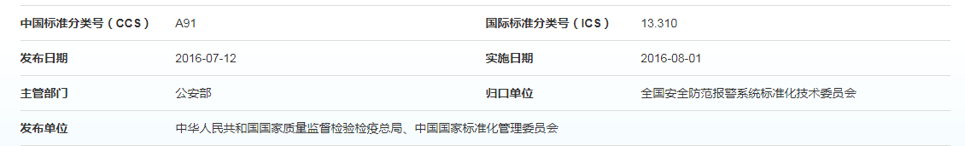
协议标准文档地址：
http://www.gb688.cn/bzgk/gb/newGbInfo?hcno=469659DC56B9B8187671FF08748CEC89
- GBT28181-2016协议
  - 略缩语
AES:高级加密标准(AdvancedEncryptionStandard)
B2BUA:背靠背用户代理(BacktoBackUserAgent)
CIF:通用中间格式(CommonIntermediateFormat)
DES:数据加密标准(DataEncryptionStandard)
DNS:域名系统(DomainNameSystem)
DVR:数字硬盘录像机(DigitalVideoRecorder)
ID:标识编码(Identification)
IP:因特网协议(InternetProtocol)
IPC:网络摄像机(InternetProtocolCamera)
IPSec:因特网安全协议(InternetProtocolSecurity)
MANSCDP:监控报警联网系统控制描述协议(MonitoringandAlarmingNetworkSystemControl
DescriptionProtocol)
MANSRTSP:监控报警联网系统实时流协议(MonitoringandAlarmingNetworkSystem Real?TimeStreamingProtocol)
MD5:信息摘要算法第5版(MessageDigestAlgorithm5)
MPEG-4:动态图像专家组 (MovingPictureExpertsGroup)
NAT/FW:网络地址翻译/防火墙(NetworkAddressTranslatorandFireWall)
NTP:网络时间协议(NetworkTimeProtocol)
NVR:网络硬盘录像机(NetworkVideoRecorder)
PS:节目流(ProgramStream)
RTCP:实时传输控制协议(Real-timeTransportControlProtocol)
RTP:实时传输协议(Real-timeTransportProtocol)
RTSP:实时流化协议(Real-TimeStreamingProtocol)
SDP:会话描述协议(SessionDescriptionProtocol)
SHA:安全哈希算法(SecureHashAlgorithm)
SIP:会话初始协议(SessionInitiationProtocol)
SVAC:安全防范监控数字视音频编码(SurveillanceVideoandAudioCoding)
S/MIME:安全多用途网际邮件扩充协议(SecureMultipurposeInternetMailExtensions)
TCP:传输控制协议(TransmissionControlProtocol)
TLS:传输层安全(TransportLayerSecurity)
UA:用户代理(UserAgent)
UAC:用户代理客户端(UserAgentClient)
UAS:用户代理服务端(UserAgentServer)
UDP:用户数据报协议(UserDatagramProtocol)
URI:全局资源标识符(UniversalResourceIdentifier)
XML:可扩展标记语言(EXtensibleMarkupLanguage)
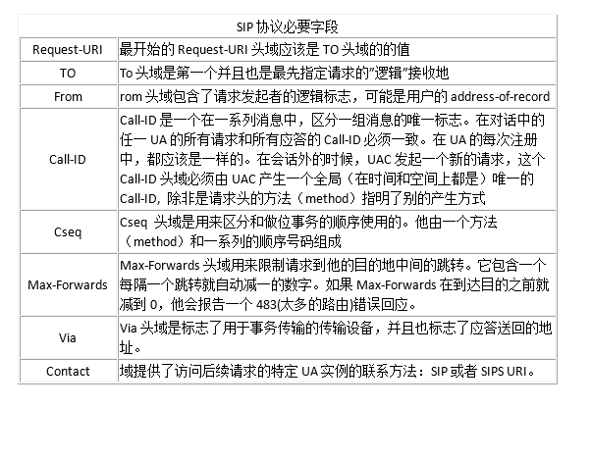
  - 互联结构
2.2.1 SIP监控域互联结构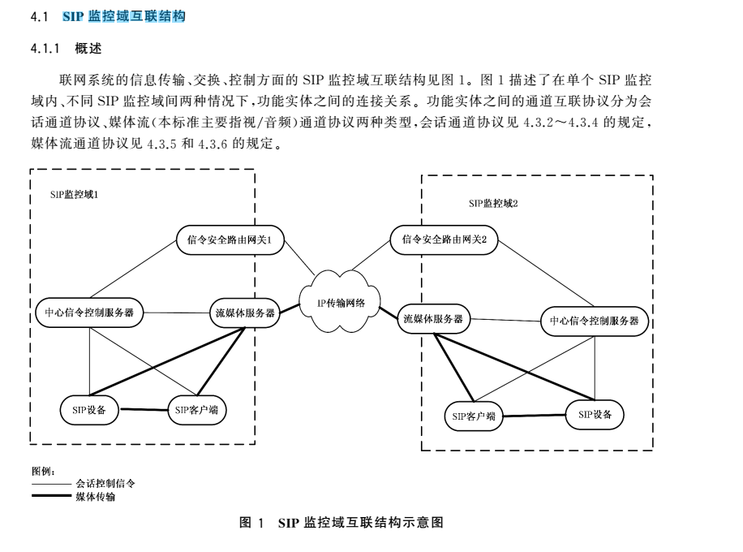
2.2.2 联网方式
2.2.2.1 级联
两个信令安全路由网关之间是上下级关系,下级信令安全路由网关主动向上级信令安全路由网关
发起注册,经上级信令安全路由网关鉴权认证后才能进行上下级系统间通信。
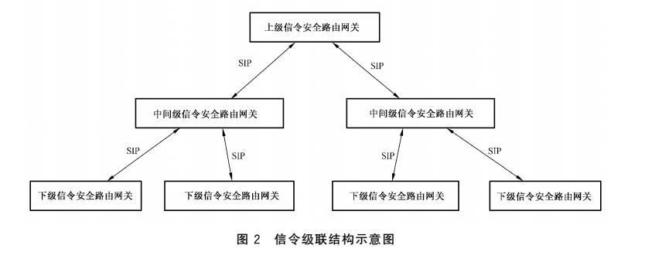
2.2.2.2
互联
信令安全路由网关之间是平级关系,需要共享对方SIP监控域的监控资源时,由信令安全路由网关
向目的信令安全路由网关发起,经目的信令安全路由网关鉴权认证后方可进行平级系统间通信。
互联方式的联网结构示意图如图4、图5所示,信令流应通过信令安全路由网关传送,媒体流宜通
过媒体服务器传送。

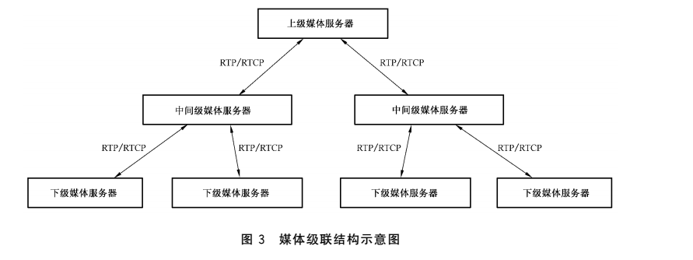
信令安全路由网关之间是平级关系,需要共享对方SIP监控域的监控资源时,由信令安全路由网关
向目的信令安全路由网关发起,经目的信令安全路由网关鉴权认证后方可进行平级系统间通信
互联方式的联网结构示意图
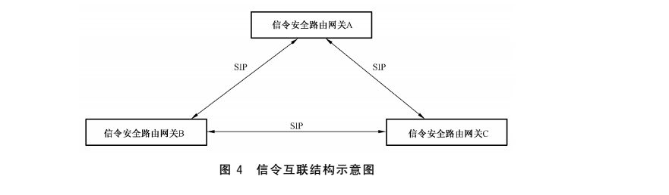
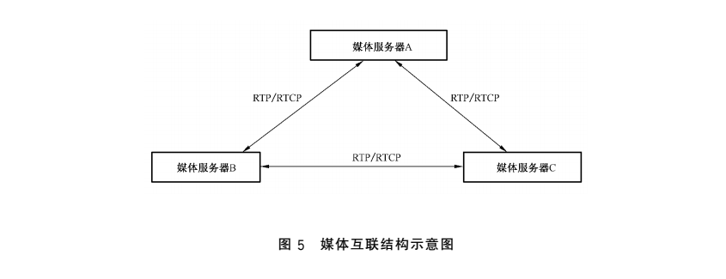
2.2.2.3 SIP监控域与非SIP监控域互联结构
SIP监控域与非SIP监控域通过网关进行互联,互联结构见图6。网关是非SIP监控域接入SIP监
控域的接口设备,在多个层次上对联网系统信息数据进行转换。根据转换的信息数据类型,网关逻辑上分为控制协议网关和媒体网关
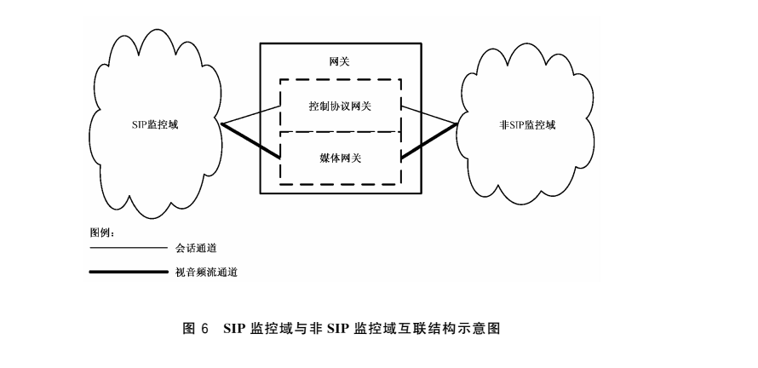
2.2.2.4 控制协议网关
控制协议网关在SIP监控域和非SIP监控域的设备之间进行网络传输协议、控制协议、设备地址的转换,具体功能应包括如下的一种或几种：
a) 代理非SIP监控域设备在SIP监控域的SIP服务器上进行注册;
b) 将非SIP监控域的网络传输协议与5.1中规定的网络传输协议进行双向协议转换;
c) 将非SIP监控域的设备控制协议与4.3中规定的会话初始协议、会话描述协议、控制描述协议和媒体回放控制协议进行双向协议转换;
d) 将非SIP监控域的设备地址与6.1中规定的设备地址进行双向地址转换。
2.2.2.5 媒体网关
媒体网关在SIP监控域和非SIP监控域的设备之间进行媒体传输协议、媒体数据编码格式的转换具体功能应包括如下的一种或者几种:
a) 将非SIP监控域的媒体传输协议和数据封装格式与5.2规定的媒体传输协议和数据封装格式进行双向协议转换;
b) 将非SIP监控域的媒体数据与6.2中规定的媒体数据压缩编码进行双向转码

2.2.3联网系统通信协议结构
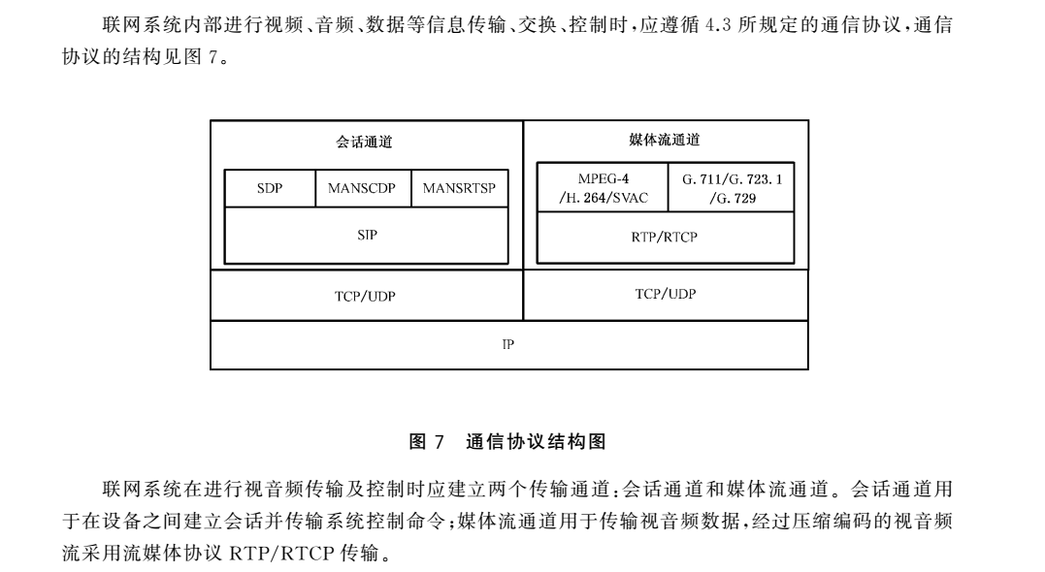
2.2.4控制、传输流程和协议接口
2.2.4.1 基本注册
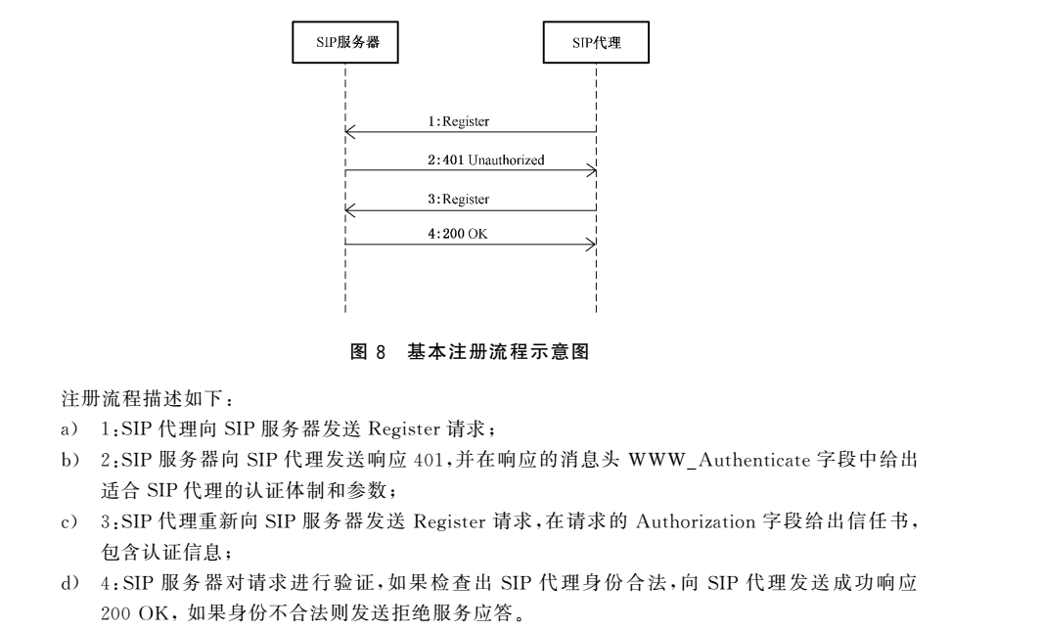
消息示范：
1.1 Registersip:SIP服务器编码@目的域名或IP地址端口SIP/2.0
Via:SIP/2.0/UDP 源域名或IP地址端口
From:<sip:SIP设备编码@源域名>;tag=185326220
To:<sip:SIP设备编码@源域名>
Call-ID:ms1214-322164710-681262131542511620107-0@172.18.16.3
CSeq:1Register
Contact:<sip:SIP设备编码@源IP地址端口>
Max-Forwards:70
Expires:3600
Content-Length:0
J.1.2 SIP/2.0401Unauthorized
To:sip:SIP设备编码@源域名
Content-Length:0
CSeq:1Register
Call-ID:ms1214-322164710-681262131542511620107-0@172.18.16.3
From:<sip:SIP设备编码@源域名>;tag=185326220
Via:SIP/2.0/UDP源域名或IP地址端口
WWW-Authenticate:Digestrealm="64010000",nonce="6fe9ba44a76be22a"
J.1.3 Registersip:SIP服务器编码@目的域名或IP地址端口 SIP/2.0
Via:SIP/2.0/UDP 源域名或IP地址端口
From:<sip:SIP设备编码@源域名>;tag=185326220
To:<sip:SIP设备编码@源域名>
Call-ID:ms1214-322164710-681262131542511620107-0@172.18.16.3
CSeq:2Register
Contact:<sip:SIP设备编码@源IP地址端口>
Authorization:Digestusername="64010000002020000001",realm="64010000",nonce="6fe9
ba44a76be22a",uri="sip:64010000002000000001@172.18.16.5:5060",response="9625d92d1bddea
7a911926e0db054968",algorithm=MD5
Max-Forwards:70
Expires:3600
Content-Length:0
115
GB/T28181—2016J.1.4 SIP/2.0200OK
To:<sip:SIP设备编码@源域名>;tag=69113a2a
Contact:sip:SIP设备编码@源IP地址端口
Content-Length:0
CSeq:2Register
Call-ID:ms1214-322164710-681262131542511620107-0@172.18.16.3
From:<sip:SIP设备编码@源域名>;tag=185326220
Via:SIP/2.0/UDP源域名或IP地址端口
Date:2010-11-02T15:01:26.115
Expires:3600
2.2.4.2 注销
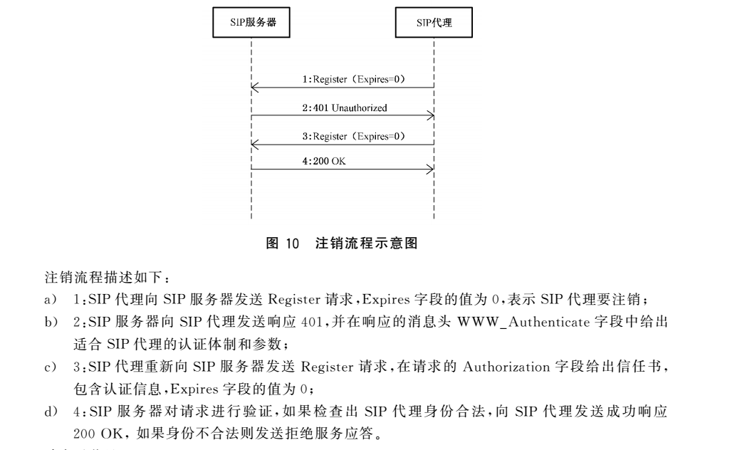
Registersip:SIP服务器编码@目的域名或IP地址端口SIP/2.0
Via:SIP/2.0/UDP 源域名或IP地址端口
From:<sip:SIP设备编码@源域名>;tag=185326220
To:<sip:SIP设备编码@源域名>
Call-ID:ms1214-322164710-681262131542511620107-0@172.18.16.3
CSeq:1Register
Contact:<sip:SIP设备编码@源IP地址端口>
Max-Forwards:70
Expires:0
Content-Length:0

2.2.4.3 设备控制
源设备向目标设备发送设备控制命令,控制命令的类型包括球机/云台控制、远程启动、录像控制、报警布防/撤防、报警复位、强制关键帧、拉框放大、拉框缩小、看守位控制、设备配置等,设备控制采用IETFRFC3428中的 Message方法实现。源设备包括SIP客户端、网关或者联网系统,目标设备包括SIP设备、网关或者联网系统。源设备向目标设备发送球机/云台控制命令、远程启动命令、强制关键帧、拉框放大、拉框缩小命令后,目标设备不发送应答命令,命令流程见9.3.2.1;源设备向目标设备发送录像控制、报警布防/撤防、报警复位、看守 位 控 制、设 备 配 置 命 令 后,目 标 设 备 应 发 送 应 答 命 令 表 示 执 行 的 结 果,命 令 流 程
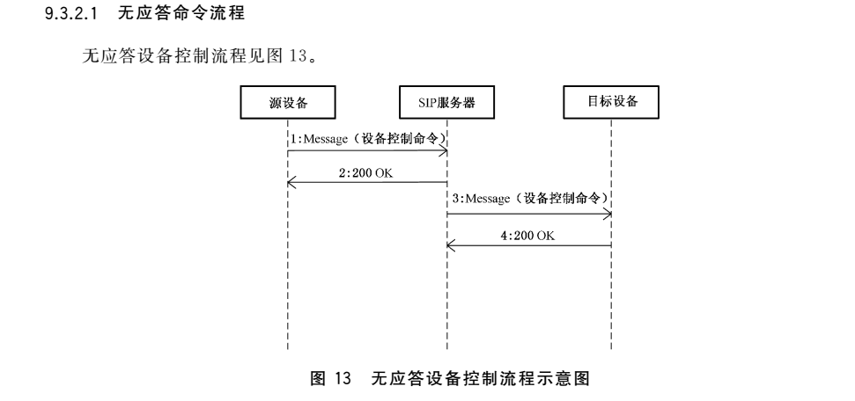

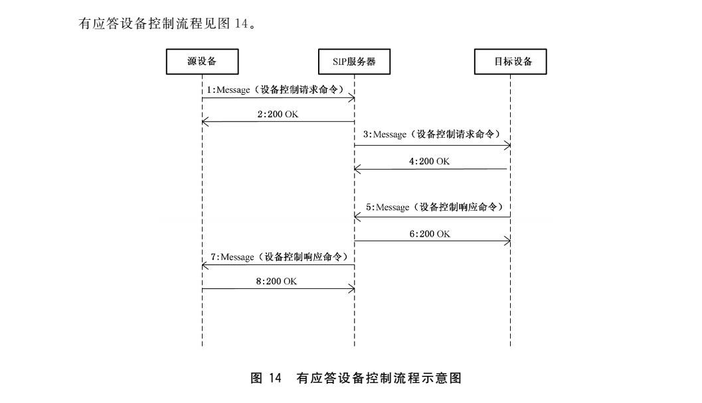

以下是样例：
说明：SPVMN平台IP为192.168.8.180，设备IP为192.168.8.184
一、向平台注册的交互协议
1、客户机向SPVMN平台注册协议
REGISTER sip:34020000002000000001@3402000000 SIP/2.0
Via: SIP/2.0/UDP 192.168.8.184:5060;rport;branch=z9hG4bK1839159132
From: <sip:34020000001320000001@3402000000>;tag=1168363890
To: <sip:34020000001320000001@3402000000>
Call-ID: 434018964
CSeq: 1 REGISTER
Contact: <sip:34020000001320000001@192.168.8.184:5060>
Max-Forwards: 70
User-Agent: IP Camera
Expires: 3600
Content-Length: 0
2、平台回复包
SIP/2.0 401 Unauthorized
CSeq: 1 REGISTER
Call-ID: 434018964
From: <sip:34020000001320000001@3402000000>;tag=1168363890
To: <sip:34020000001320000001@3402000000>;tag=90691234_53173353_a67d0e0e-e55c-4ac7-9d5a-f78e149aaf81
Via: SIP/2.0/UDP 192.168.8.184:5060;rport=5060;branch=z9hG4bK1839159132;received=192.168.8.184
WWW-Authenticate: Digest realm="3402000000",nonce="b1f444e6805f2768"
Content-Length: 0
3、验证注册
REGISTER sip:34020000002000000001@3402000000 SIP/2.0
Via: SIP/2.0/UDP 192.168.8.184:5060;rport;branch=z9hG4bK119722870
From: <sip:34020000001320000001@3402000000>;tag=1168363890
To: <sip:34020000001320000001@3402000000>
Call-ID: 434018964
CSeq: 2 REGISTER
Contact: <sip:34020000001320000001@192.168.8.184:5060>
Authorization: Digest username="34020000001320000001", realm="3402000000", nonce="b1f444e6805f2768", uri="sip:34020000002000000001@3402000000", response="97cae60143bf336443d0bc5e669571a9", algorithm=MD5
Max-Forwards: 70
User-Agent: IP Camera
Expires: 3600
Content-Length: 0
4、平台回复
SIP/2.0 200 OK
CSeq: 2 REGISTER
Call-ID: 434018964
From: <sip:34020000001320000001@3402000000>;tag=1168363890
To: <sip:34020000001320000001@3402000000>;tag=02949493_53173353_db24af08-e421-4de3-85e7-b3f3f5284b02
Via: SIP/2.0/UDP 192.168.8.184:5060;rport=5060;branch=z9hG4bK119722870;received=192.168.8.184
Contact: <sip:34020000001320000001@192.168.8.184:5060>
Expires: 3600
Date: 2015-11-05T10:55:56.012
Content-Length: 0

5、客户端向平台的消息请求包
MESSAGE sip:34020000002000000001@3402000000 SIP/2.0
Via: SIP/2.0/UDP 192.168.8.184:5060;rport;branch=z9hG4bK10460200
From: <sip:34020000001320000001@3402000000>;tag=1056449357
To: <sip:34020000002000000001@3402000000>
Call-ID: 897764098
CSeq: 20 MESSAGE
Content-Type: Application/MANSCDP+xml
Max-Forwards: 70
User-Agent: IP Camera
Content-Length: 162

<?xml version="1.0" encoding="UTF-8"?>
<Notify>
<CmdType>Keepalive</CmdType>
<SN>105</SN>
<DeviceID>34020000001320000001</DeviceID>
<Status>OK</Status>
</Notify>
6、平台回复
D?IWEge<@SSIP/2.0 200 OK
CSeq: 20 MESSAGE
Call-ID: 897764098
From: <sip:34020000001320000001@3402000000>;tag=1056449357
To: <sip:34020000002000000001@3402000000>;tag=32617088_53173353_9281af7a-b890-44e0-8033-2f61d4af7c64
Via: SIP/2.0/UDP 192.168.8.184:5060;rport=5060;branch=z9hG4bK10460200;received=192.168.8.184
Content-Length: 0
到此，注册成功。

二、视频播放协议
2.1 平台向设备请求数据
INVITE sip:34020000001320000001@3402000000 SIP/2.0
Call-ID: 8da28ff25846846583477063d4008180@0.0.0.0
CSeq: 1 INVITE
From: <sip:34020000002000000001@3402000000>;tag=41363971_53173353_e9868597-2a56-4171-911d-d527eb58c307
To: <sip:34020000001320000001@3402000000>
Max-Forwards: 70
Contact: "34020000002000000001" <sip:<span style="font-family: Arial, Helvetica, sans-serif;">192.168.8.180</span><span style="font-family: Arial, Helvetica, sans-serif;">:5060></span>
Content-Type: application/sdp
Route: <sip:34020000001320000001@192.168.8.184:5060;lr>
Via: SIP/2.0/UDP 192.168.8.180:5060;branch=z9hG4bKe9868597-2a56-4171-911d-d527eb58c307_53173353_50921343723068
Content-Length: 225

v=0
o=34020000002020000001 0 0 IN IP4 192.168.8.180
s=Play
c=IN IP4 192.168.8.180
t=0 0
m=video 6000 RTP/AVP 96 98 97
a=recvonly
a=rtpmap:96 PS/90000
a=rtpmap:98 H264/90000
a=rtpmap:97 MPEG4/90000
y=0100000001
f=
2.2 设备回复平台的包
SIP/2.0 100 Trying
Via: SIP/2.0/UDP 192.168.8.180:5060;branch=z9hG4bKe9868597-2a56-4171-911d-d527eb58c307_53173353_50921343723068;received=192.168.8.180
From: <sip:34020000002000000001@3402000000>;tag=41363971_53173353_e9868597-2a56-4171-911d-d527eb58c307
To: <sip:34020000001320000001@3402000000>
Call-ID: 8da28ff25846846583477063d4008180@0.0.0.0
CSeq: 1 INVITE
User-Agent: IP Camera
Content-Length: 0

SIP/2.0 200 OK
Via: SIP/2.0/UDP 192.168.8.180:5060;branch=z9hG4bKe9868597-2a56-4171-911d-d527eb58c307_53173353_50921343723068;received=192.168.8.180
From: <sip:34020000002000000001@3402000000>;tag=41363971_53173353_e9868597-2a56-4171-911d-d527eb58c307
To: <sip:34020000001320000001@3402000000>;tag=833711816
Call-ID: 8da28ff25846846583477063d4008180@0.0.0.0
CSeq: 1 INVITE
Contact: <sip:34020000001320000001@192.168.8.184:5060>
Content-Type: application/sdp
User-Agent: IP Camera
Content-Length: 227

v=0
o=34020000001320000001 3238 3238 IN IP4 192.168.8.184
s=play
c=IN IP4 192.168.8.184
t=0 0
m=video 15060 RTP/AVP 96
a=sendonly
a=rtpmap:96 PS/90000
a=username:34020000001320000001
a=password:12345678
y=0100000001

2.3 平台发给设备的ACK，设备收到这个包后，就可以向平台发送RTP数据了
ACK sip:34020000001320000001@192.168.8.184:5060 SIP/2.0
Call-ID: 8da28ff25846846583477063d4008180@0.0.0.0
CSeq: 1 ACK
From: <sip:34020000002000000001@3402000000>;tag=41363971_53173353_e9868597-2a56-4171-911d-d527eb58c307
To: <sip:34020000001320000001@3402000000>;tag=833711816
Max-Forwards: 70
Via: SIP/2.0/UDP 192.168.8.180:5060;branch=z9hG4bKe9868597-2a56-4171-911d-d527eb58c307_53173353_50921370541873
Content-Length: 0

